|  |  |
| --- | --- |
| CSA0496 | Operating Systems for Segmentation |

**Optimizing Multicore Process Scheduling for Efficiency in Operating Systems**

Suthesan vj kavinkumar e Surya Karthik

192210542 192224243 192221108

**Introduction:**

In the landscape of contemporary computing, the prevalence of multicore processors has become pervasive, promising increased computational power and improved system performance. These processors, equipped with multiple cores, enable concurrent execution of tasks, but to fully realize their potential, operating systems must implement efficient scheduling strategies. This article delves into the intricacies of optimizing multicore process scheduling to achieve efficiency in operating systems.

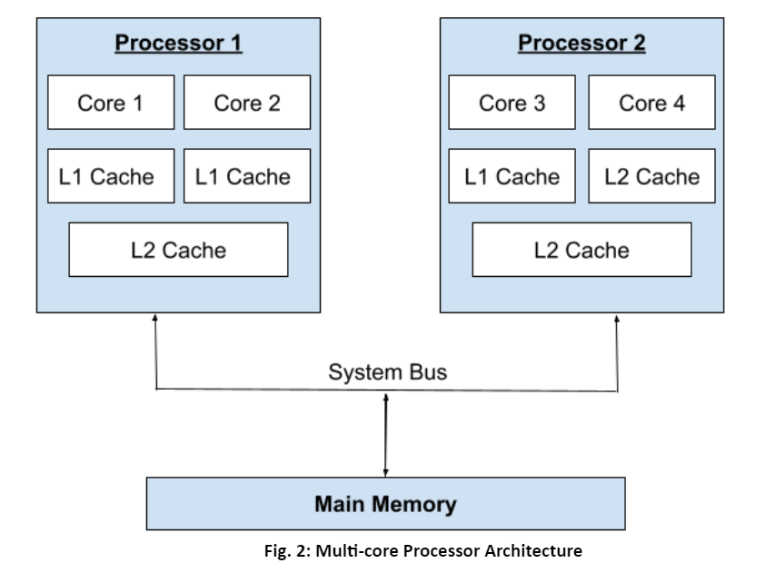

**Understanding Multicore Processors:**

A multicore processor houses multiple processing units (cores) on a single chip, allowing the system to execute independent tasks concurrently. Unlike single-core processors, multicore architectures provide inherent parallelism, presenting both opportunities and challenges for operating systems.

**Importance of Efficient Multicore Scheduling:**

1. **Enhanced Performance:** Multicore processors promise improved system performance by enabling simultaneous execution of multiple tasks. Efficient scheduling ensures that all available cores are actively utilized, leading to reduced latency and faster task execution.
2. **Resource Optimization:** Efficient scheduling prevents resource contention, where multiple processes compete for the same core. Balanced distribution of tasks across cores maximizes resource utilization, preventing bottlenecks and ensuring optimal performance.
3. **Energy Efficiency:** Optimized multicore scheduling contributes to energy efficiency. By distributing tasks evenly and minimizing idle time, the system can effectively manage power consumption—a critical consideration for battery-powered devices and energy-conscious data centers.

**Challenges in Multicore Scheduling:**

1. **Load Imbalance:** Unequal distribution of tasks among cores can lead to load imbalance. Some cores may be underutilized while others are overwhelmed, resulting in suboptimal performance. Efficient scheduling strategies aim to balance the workload evenly across all cores.
2. **Thread Synchronization:** Coordinating the execution of multiple threads is essential for preventing data corruption and ensuring consistency. Scheduling algorithms must incorporate synchronization mechanisms to manage shared resources and maintain system integrity.
3. **Scalability:** As the number of cores increases, scalability becomes crucial. Scheduling algorithms need to scale efficiently with the number of cores, ensuring that the system performs optimally in diverse hardware configurations.

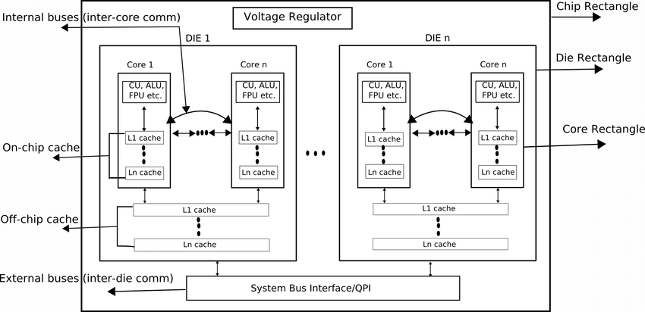

**Strategies for Optimizing Multicore Scheduling:**

1. **Affinity Scheduling:** Affinity scheduling involves assigning specific tasks to designated cores. This strategy enhances cache locality, reducing memory access times and minimizing the need for data migration between caches.
2. **Load Balancing:** Dynamic load balancing analyzes each core's workload in real-time and redistributes tasks accordingly. This adaptive approach prevents the system from becoming bottlenecked by a single overloaded core, ensuring optimal performance.
3. **Task Parallelism:** Decomposing tasks into smaller, parallelizable units allows for efficient utilization of multiple cores. Operating systems can employ task parallelism to execute independent units concurrently, maximizing overall system throughput.

**Case Studies and Advances:**

1. **Linux Completely Fair Scheduler (CFS):** The Linux CFS is designed to provide fair access to CPU resources for all tasks. Advances, such as the Group Scheduling Control (GSC) patch, aim to improve scalability and fairness in multicore environments.
2. **Intel's Concurrency Runtime:** Intel's Concurrency Runtime library simplifies parallel programming by offering features such as automatic load balancing and task stealing. These tools empower developers to optimize multicore performance efficiently.

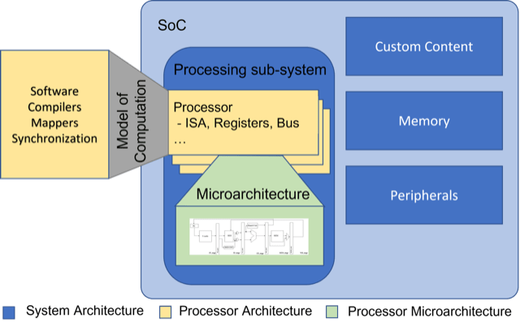

**Results and Discussion:**

The implementation of efficient multicore scheduling strategies yields tangible results in terms of system performance and resource utilization. In scenarios where load balancing is achieved, the overall responsiveness of the system improves, preventing individual cores from being overwhelmed. The optimization of affinity scheduling enhances cache utilization, reducing memory access times and improving computational efficiency.

Moreover, advances in multicore scheduling, as demonstrated by the Linux CFS and Intel's Concurrency Runtime, showcase the ongoing efforts to address challenges such as load imbalance and scalability. The Group Scheduling Control patch for the Linux CFS, for example, contributes to fair resource allocation among processes, mitigating potential bottlenecks.

The emphasis on task parallelism as a scheduling strategy allows operating systems to leverage the full potential of multicore processors, resulting in improved throughput for parallelizable workloads. These advances collectively contribute to the efficient utilization of multicore architectures, ensuring that the benefits of parallel processing are realized without compromising system stability.

**Conclusion:**

Efficiently managing multicore processors is fundamental to modern operating system design. As hardware continues to advance, optimizing process scheduling becomes pivotal. Operating systems must adapt and implement advanced scheduling strategies to harness the full potential of multicore architectures. Through innovations in scheduling algorithms, load balancing, and task parallelism, the efficiency of operating systems in multicore environments can be significantly enhanced. The quest for optimal multicore scheduling is a dynamic field, continually evolving to meet the demands of an ever-changing computing landscape. The results and discussions presented here underscore the importance of these optimizations, showcasing the real-world impact on system performance and responsiveness.